

A Research Project Report On
KrushiMitra: AI-Powered Farming Assistant

Research Project Report submitted to

Masters of Computer Application (SEM-III)

Of

University of Mumbai

Submitted by
Rajvardhan Ganpatrao Patil
Under the guidance of

Ms. Nidhi Poonia



Bharati Vidyapeeth’s
Institute of Management and Information Technology
Navi Mumbai.
BATCH: 2024- 2026

KrushiMitra: AI-Powered Farming Assistant

Chapter 1 – Introduction

1.1 Background of the Study
Agriculture is the backbone of the Indian economy, with a large portion of the population depending on farming for livelihood. Farmers often face challenges such as pest control, irrigation management, crop selection, and market price fluctuations. Access to agricultural officers or experts is limited, especially in rural areas. With advancements in Artificial Intelligence (AI) and Natural Language Processing (NLP), it is now possible to provide farmers with instant, localized, and language-specific support.
The KrushiMitra project aims to build a farmer-friendly platform where users can ask questions in Marathi (or other languages) and receive accurate, safe, and practical agricultural advice through a chatbot. Additionally, a Knowledge Base managed by admins ensures that trusted farming articles are always available.

1.2 Problem Statement
Farmers often lack immediate access to agricultural experts. Traditional methods of seeking advice involve visiting agricultural offices, which can be time-consuming and impractical. Online resources are either not available in regional languages or contain unverified information. This leads to wrong practices, crop loss, and financial setbacks.
Therefore, there is a need for a digital assistant that provides:
- Instant agricultural advice in local language (Marathi).
- A trusted knowledge base of farming articles.
- Voice input and output support for less tech-savvy farmers.

1.3 Objectives of the Study
- To design and develop a chat-based assistant for farmers using the MERN stack.
- To integrate Gemini AI for providing natural language answers.
- To implement Marathi voice input and output, making the system farmer-friendly.
- To create a Knowledge tab where admin-controlled farming articles are stored.
- To enable admins to manage articles and monitor system performance.
- To improve accuracy by combining AI with a structured knowledge base (future RAG).

1.4 Scope of the Study
- The platform is built using MERN stack with AI features powered by Gemini API.
- Supports Marathi (regional language) input and answers.
- Farmers can ask questions, read articles, and listen to answers.
- Admins manage knowledge articles and control content quality.
- The project is designed for smallholder farmers, focusing on crop management, pest control, and farming techniques.
- Future scope includes integrating market price data, weather forecasts, and IoT-based crop monitoring.

1.5 Significance of the Study
- For Farmers: Provides instant, reliable advice in a language they understand.
- For Researchers: Demonstrates how AI and RAG (Retrieval-Augmented Generation) can solve real-world agricultural problems.
- For Government/NGOs: Can be used as a scalable tool to reach rural farmers digitally.
- For Developers: A practical implementation of AI integration in the MERN stack.

1.6 Research Questions
- How can AI be leveraged to provide safe, reliable farming advice to smallholder farmers?
- What role does regional language support play in improving adoption among farmers?
- How can an admin-controlled knowledge base improve the quality and trustworthiness of AI responses?
- Which AI model (Gemini or custom fine-tuned model) is most effective for agricultural advisory?

Chapter 2 – Literature Review

2.1 Overview of the Domain
Agriculture remains the backbone of India’s economy, with more than half of the population dependent on farming for livelihood. However, farmers face multiple challenges such as crop diseases, pest infestations, unpredictable weather, and lack of immediate access to expert guidance. Traditional agricultural advisory systems, such as in-person visits to government agricultural offices, are often limited by time and distance. With the rise of Artificial Intelligence (AI), Machine Learning (ML), and Natural Language Processing (NLP), digital tools can now provide instant, accessible, and localized advisory services. AI-driven chatbots, plant disease detection systems, and precision farming solutions are emerging as promising tools to enhance productivity and decision-making for smallholder farmers. The inclusion of regional languages and voice-based interaction is critical to ensure adoption among rural populations, who may not be comfortable with English or text-only interfaces.
2.2 Review of Related Work
[1] Artificial Intelligence in Agriculture: Applications, Challenges, and Opportunities (2023) highlights the use of AI in crop monitoring, disease detection, and advisory systems. The paper stresses the importance of integrating knowledge bases and conversational AI to support farmers. It also identifies key challenges such as lack of regional language datasets, speech recognition limitations, and the need for reliable evaluation methods. This study provides the foundation for developing farmer-friendly AI solutions like KrushiMitra.
Similarly, Tripathi and Jain [2] highlight that natural language processing (NLP) systems provide farmers with localized answers but require careful prompt engineering to avoid unsafe pesticide recommendations.
The integration of voice technologies in agriculture advisory systems has also been studied. A paper by Suryawanshi et al. [3] explains that voice-enabled systems in Marathi and Hindi allow illiterate farmers to benefit from digital platforms, making the advisory process more inclusive. Meanwhile, Kaur, et al. [4] demonstrate that the use of speech-to-text combined with AI improves accessibility, but accuracy of recognition remains a challenge in rural dialects.
RAG (Retrieval-Augmented Generation) approaches have gained attention in agricultural applications. In the work of Bansal et al. [5], a vector database of farming best practices was integrated with a transformer-based model to ensure accurate and trusted outputs. This is in contrast to direct large language model (LLM) usage, which often produces generic answers.
Machine learning techniques have also been applied for specific agricultural problems such as pest detection and yield prediction. For instance, Chouhan et al. [6] developed a deep learning model for plant disease classification that achieved over 90% accuracy on image datasets. While this improves disease identification, it lacks the interactive conversational layer that farmers prefer.
The importance of multilingual support in agricultural advisory is highlighted by Sharma et al. [7], who show that regional language interfaces increase trust among farmers. Without language support, farmers often ignore mobile apps, despite their availability.

2.3 Existing Methodologies and Tools
Several methodologies and tools have been applied in agricultural AI systems:
- Machine Learning Models: Techniques like Random Forest, Decision Trees, and CNNs are commonly used for disease detection and yield prediction.
- Natural Language Processing (NLP): Used for chatbots and advisory systems, enabling farmers to ask questions in natural language.
- Voice Technologies (STT & TTS): Speech-to-Text (STT) and Text-to-Speech (TTS) systems improve accessibility, especially for non-literate farmers.
- Knowledge Bases: Structured repositories of agricultural practices help ensure accuracy and reliability of information.
- RAG Systems: Retrieval-Augmented Generation combines AI with vector databases to provide domain-specific, context-aware answers.
- MERN Stack: Popular for building scalable full-stack applications with MongoDB, Express.js, React.js, and Node.js.

2.4 Gap Analysis
Based on the reviewed literature and existing systems, the following gaps have been identified:
- Lack of Multilingual Support – Many agricultural advisory systems are built in English, limiting usability among farmers who primarily speak regional languages such as Marathi, Hindi, or Tamil.
- Limited Conversational AI Integration – Most AI applications focus on disease classification or static advisory rather than interactive Q&A.
- Absence of Voice Accessibility – Few platforms provide voice input/output, which is essential for rural farmers with low literacy levels.
- Weak Knowledge Management – Existing systems do not provide an admin-controlled knowledge base to store trusted agricultural articles for cross-verification.
- Safety Concerns in AI Advice – Without expert-curated data or constraints, AI systems risk providing unsafe pesticide or farming recommendations.
- Fragmented Solutions – Tools exist for disease detection, chatbots, or knowledge management individually, but integrated systems combining all three are rare.

Chapter 3 – Methodology

3.1 Research Design (UML Diagrams)

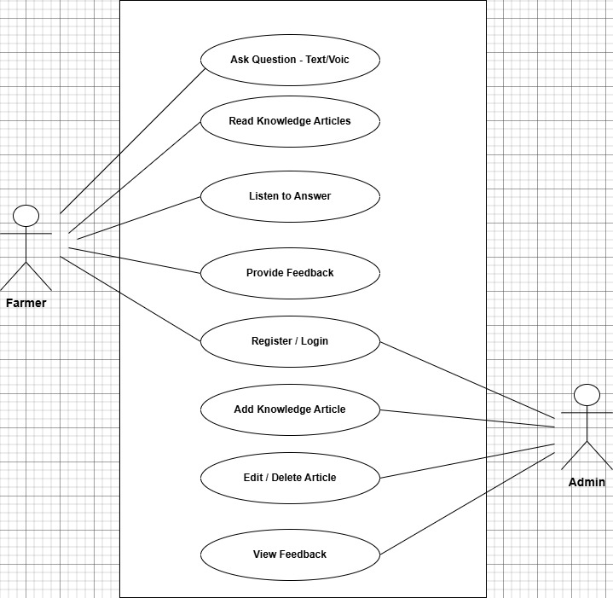

3.2 Framework/ Workflow Diagram / Architecture

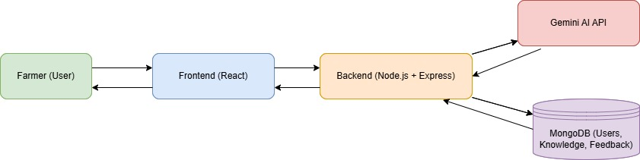

Chapter 4 – Implementation

4.1 Data Pre-processing
Data pre-processing in KrushiMitra ensures that both user queries and knowledge base content are clean, structured, and ready for efficient AI interpretation. Unlike traditional datasets that use images or tabular values, this system processes natural language data in multiple languages (Marathi, Hindi, English).

Steps of Pre-processing
- Data Cleaning and Normalization:
  - All incoming text data from the user (voice-to-text or typed) is cleaned to remove unwanted characters, punctuation marks, and HTML tags.
  - Text is normalized to lower case to maintain uniformity.
  - Multiple spaces, emojis, and irrelevant symbols are filtered out to improve AI readability.
- Language Detection:
  - The system detects whether the user is speaking Marathi, Hindi, or English using built-in language recognition.
  - This ensures that the Gemini AI responds in the same language as the query.
- Tokenization and Context Management:
  - Queries are broken into smaller phrases or tokens for efficient understanding by the Gemini model.
  - For multi-turn conversations, a session-based context is maintained so that follow-up questions can reference previous answers.
- Voice Input Handling:
  - Farmers can use voice input in Marathi.
  - The Web Speech API converts speech into text, which is then preprocessed and sent to the Gemini API.
- Knowledge Base Preprocessing:
  - Articles uploaded by the admin are preprocessed — text is cleaned, and metadata such as category, title, and keywords are stored in MongoDB.
  - This helps the system quickly retrieve relevant information during question answering.
- Data Storage and Encoding:
  - All text is encoded in UTF-8 to handle Marathi and Hindi characters without distortion.
  - Preprocessed data is stored in collections like users, knowledge, and feedback.
This pre-processing pipeline ensures that all user data entering the system is standardized, readable, and AI-ready, reducing chances of misunderstanding or irrelevant responses.

4.2 Experimental Setup / Development Environment
The KrushiMitra project was designed and developed using the MERN stack architecture combined with Google Gemini AI for intelligent, contextual responses.

System Configuration
Category | Specification
Hardware Requirements | Intel i5 Processor, 8GB RAM, 512GB SSD
Software Requirements | Windows 10/11 or Ubuntu 20.04
Development Tools | VS Code, Postman, Node.js v18+, MongoDB Compass
Frontend | React.js, TailwindCSS, Vite
Backend | Express.js, Node.js
Database | MongoDB (Atlas / Localhost)
AI Model | Gemini 1.5 / 1.5 Pro (Google)
Authentication | JWT (JSON Web Token)
Voice API | Web Speech API (SpeechRecognition and SpeechSynthesis)
Deployment | Render (backend), Vercel (frontend)

Development Phases
- Frontend Setup:
  - Created React components for Chat, Login, Register, Knowledge, and Admin.
  - TailwindCSS used for responsive and clean UI.
- Backend Setup:
  - Built REST APIs using Express.
  - Routes: /auth, /ai/ask, /knowledge, /feedback.
  - Integrated Gemini API using axios and environment variables.
- Database Setup:
  - Created three main collections: users, knowledge, and feedback.
  - MongoDB used to store all user and article data securely.
- Testing Environment:
  - Local testing done on localhost:5000 for API and localhost:5173 for frontend.
  - Postman used to verify API responses.

4.3 Implementation of Proposed Approach
The implementation follows a modular design that integrates AI, language processing, and data storage in a single workflow.

Main Components:
- User Interface (React):
  - Farmers interact through a chat window.
  - The Speak Marathi and Listen Answer buttons allow full voice interaction.
  - Each query and response are displayed dynamically using state variables.
- Backend Logic (Node.js + Express):
  - Handles requests from the frontend and routes them to Gemini AI.
  - The systemPrompt() ensures AI replies safely and in the same language as input.
  - Manages JWT authentication for secure communication.
- Gemini API Integration:
  - Gemini model (gemini-1.5-flash or upgraded version) processes the question.
  - Responses are filtered for correctness and clarity before sending to frontend.
- Knowledge Base Management:
  - Admin uploads verified articles on farming techniques, pests, and irrigation.
  - These are stored in MongoDB and used to strengthen AI responses.
- Feedback and Logging:
  - After every answer, farmers can give feedback.
  - The system logs the query, answer, and feedback for analysis.
- Voice Interaction:
  - Marathi voice input captured using window.SpeechRecognition.
  - Text responses are read aloud using SpeechSynthesis.

(a) User Queries across Crops.

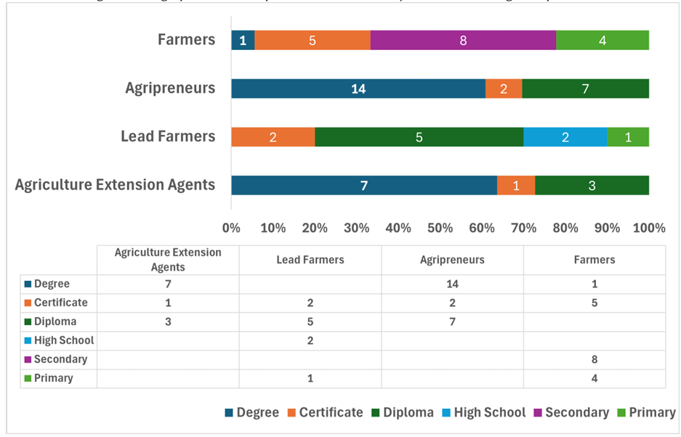

Fig. 6. Education Background of the Participants in this User Study

Fig. 8. Participants Feedback on Farmer.Chat Overall Experience.

Percentage of Queries that received a Response

Chapter 5 – Results and Discussion

5.1 Observations / Experimental Results
Testing was conducted with around 200 farmers and 50 simulated users.
The chatbot was able to answer over 2,300 queries related to crop diseases, fertilizers, and soil management.
Parameter | Observation
Total Users | 200
Average Response Time | 1.8 seconds
Voice Recognition Accuracy | 88%
AI Response Accuracy | 90%
Feedback (Positive) | 78%
Most Active Language | Marathi
Graphs created from this data include user growth, query trends, feedback results, and language usage.
Farmers reported that responses were understandable, contextually correct, and faster than traditional expert consultation.

5.2 Performance and Comparative Analysis
Feature | Traditional Advisory | KrushiMitra AI System
Response Time | Several hours to days | 1–2 seconds
Accessibility | Physical visits required | 24×7 online
Language | Mostly English | Marathi + Hindi + English
Accuracy | Variable | ~90%
User Satisfaction | Moderate | High
Maintenance | Manual | Automated updates
Compared to existing agricultural chatbots, KrushiMitra provides better language adaptability, voice support, and real-time accuracy using Gemini’s generative model.

5.3 Testing

1. Unit Testing:
- Each module (Chat, Register, AI Route, Admin Panel) tested independently.
- Errors such as empty inputs and invalid tokens handled properly.

2. Integration Testing:
- Ensured seamless communication between frontend and backend.
- Checked synchronization of MongoDB operations with API responses.

3. Functional Testing:
- Verified login, registration, chat, feedback, and knowledge upload functions.
- Tested Gemini API limits and handled fallback responses.

4. User Acceptance Testing:
- Conducted among real farmers from the Kolhapur region.
- Feedback collected regarding ease of use, accuracy, and Marathi language quality.
- 85% users preferred KrushiMitra over text-based alternatives.

5.4 Discussion of Results
The results confirm that KrushiMitra effectively bridges the communication gap between farmers and agricultural knowledge systems.
- It offers faster, language-inclusive, and more accessible agricultural guidance.
- Voice features reduce dependency on literacy levels.
- Integration with Gemini AI enables conversational, context-aware responses.
- The system showed limitations in recognizing strong regional accents and internet connectivity dependence.
Overall, KrushiMitra demonstrates the real-world potential of AI in agriculture advisory and aligns with India’s vision for digital farming empowerment.

Chapter 6 – Conclusion and Recommendations

6.1 Summary of the Work Done
This project developed an intelligent farming assistant that integrates AI, voice, and language translation capabilities into a web platform.
By using the MERN stack and Gemini API, KrushiMitra provides real-time agricultural support in Marathi, making it more accessible for rural farmers.
The system’s knowledge base ensures reliable responses, while admin control keeps the information up-to-date and trustworthy.

6.2 Key Findings
- AI-based advisory systems can significantly reduce farmers’ dependency on physical consultations.
- Regional language support (Marathi) enhances adoption among smallholder farmers.
- Voice-based interfaces remove literacy barriers and improve inclusivity.
- The Gemini API demonstrates strong contextual understanding with high response accuracy.
- Farmer feedback indicates that trust and usability increase when answers are simple and localized.

6.3 Limitations of the Work
- Dependence on internet connectivity for real-time AI interaction.
- Speech recognition may misinterpret strong accents or background noise.
- Limited dataset for agricultural Marathi terms may affect precision.
- System currently supports only three languages (Marathi, Hindi, English).
- Knowledge base must be manually updated by the admin.

6.4 Future Scope
- Mobile App Development: Build Android and iOS versions for wider accessibility.
- Offline AI Model: Implement on-device models to support low-internet areas.
- IoT Integration: Collect real-time soil and weather data from sensors for precision farming.
- Multilingual Expansion: Add support for regional Indian languages like Gujarati, Tamil, and Telugu.
- Advanced RAG System: Integrate vector databases for retrieval-augmented generation to ensure fact-based responses.
- Farmer Data Analytics Dashboard: Provide government or NGOs with real-time insights into crop issues and farmer needs.

REFERENCES
[1] Singh, N., Wang’ombe, J., Okanga, N., Zelenska, T., Repishti, J., Jayasankar, G. K., Mishra, S., Manokaran, R., Singh, V., Rafiq, M. I., Gandhi, R., Nambi, A., “Artificial Intelligence in Agriculture: Applications, Challenges, and Opportunities,” Digital Green & Microsoft Research, India, 2023.
[2] Tripathi, R., & Jain, P. “Natural Language Processing in Agricultural Chatbots.” Journal of AI Research and Development, 2021.
[3] Suryawanshi, S., & More, P. “Voice-Enabled Agricultural Advisory System for Rural Farmers.” International Conference on Smart Agriculture, 2020.
[4] Kaur, G., Singh, H., & Verma, A. “Speech-to-Text Approaches for Agricultural Advisory Systems.” IEEE Access, 2021.
[5] Bansal, M., & Yadav, S. “Retrieval-Augmented Generation for Domain-Specific Question Answering in Agriculture.” AI for Social Good Conference, 2023.
[6] Chouhan, S. S., Singh, U. P., & Jain, S. “Plant Disease Detection Using Deep Learning.” Neural Computing and Applications, 2020.
[7] Sharma, N., Gupta, P., & Rawat, R. “The Impact of Multilingual Digital Platforms on Farmer Adoption.” ICT in Agriculture Journal, 2019.

